SUPPLY CHAIN DELIVERY PERFORMANCE REPORT
(END-TO-END ORDER FULFILMENT ANALYSIS AND PREDICTIVE INSIGHTS)
TABLE OF CONTENTS
- Executive Summary
- Business Context & Objectives
- Key Performance Indicators (KPIs)
- Profitability Analysis
4.1) Profitability Distribution
4.2) Deay Distribution & Profit vs. Delay Days
- Bottleneck Detection
- Root Cause Analysis
- Time- Based Delay Patterns
- Strategic Recommendations
- Conclusions

- Executive Summary
This report presents a comprehensive analysis of the delivery operations of a global e-commerce company managing end-to-end order fulfilment across multiple regions . The analysis covers 1,80,519 orders spanning January 2025 through January 2018, focusing on identifying root causes of chronic late deliveries, quantifying their financial impact and establishing a data-driven framework for improvement.
The headline finding is stark: 54.70% of all orders are delivered late, costing the business $2.1M in eroded profitability on delayed orders alone. While total profit across fulfilled orders reached $7.9M. The persistent late-delivery problem represents both a significant financial drain and a major customer experience risk.

Key Finding | Metric
Overall Late Delivery rate | 54.70%
On-Time Delivery Rate | 45.30%
Total Orders Analysed | 180519
Total Profit (Profitable orders) | $7.9M
Profit at Risk (Delayed orders) | $2.1M

- Business Context and Objectives
The company operates a global e-commerce platform selling products across categories including sporting goods, fitness equipment, outdoor gear, footwear and apparel across multiple international regions.

Core Business Problem
Actual shipping times frequently deviate from scheduled delivery windows, creating eroded customer trust, reduced order profitability, and an inability to make reliable commitments to buyers at point of purchase.

Analytical Objectives
- Understand the current state of delivery performance across all dimensions (region, mode, time, segment).
- Quantify the financial impact of delays of order profitability.
- Identify the primary operational bottlenecks driving late deliveries.
- Deliver actionable recommendations to improve on-time delivery and profitability.

- Key Performance Indicators (KPIs)
The following KPIs were computed directly from the cleaned dataset to establish a performance baseline.

180519  Total orders | 98743  Late Deliveries | 54.70%  Late-Delivery % | 45.30%  On-Time Delivery%

$7.9M  Total profit (Profitable orders) | $2.1M  Profit at Risk (Delayed- orders) | 3 days  90th percentile Delay | $22.03  Avg Order Profit

- Profitability Analysis

  - Profitability Distribution
Order level profitability was classified into 3-tiers based on Order Profit Per Order. While 80.7% of orders are profitable, the 18.7% loss-making share represents a meaningful drag that is disproportionately concentrated among delayed shipments.

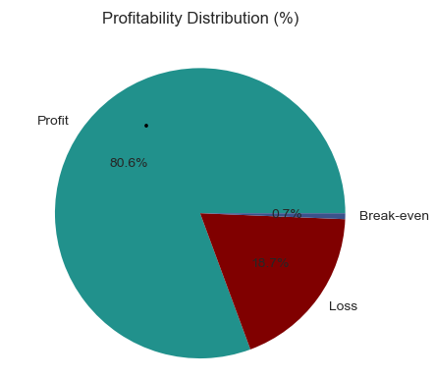
  - Delay Distribution & Profit vs. Delay Day
The delay distribution shows that 31.0% of all orders arrive exactly 1 day late the single largest cohort. Combined, orders delayed by 1-4 days account for 54.7% of all order volume, directly mapping to the overall late delivery rate.
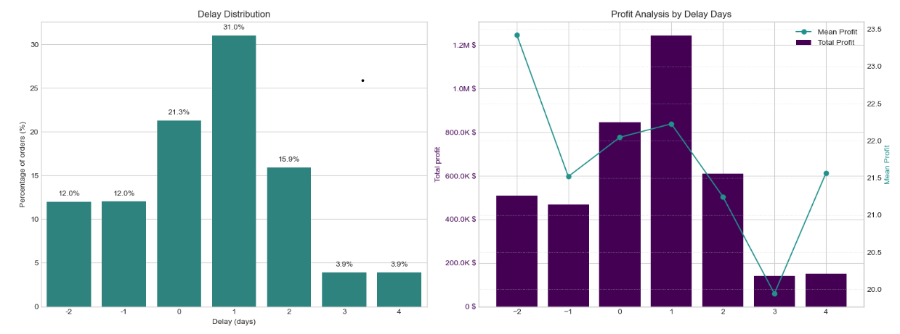

A critical observation: mean profit per order remains stable at approximately $21-$23 across all delay levels. The profitability problem is therefore driven by volume of delayed orders, not by individual order economics making systemic throughput improvement the highest-leverage intervention.

- Bottleneck Detection
- Delay percentage was computed across six key operational dimensions. The charts below reveal where the fulfilment process breaks down most severely.
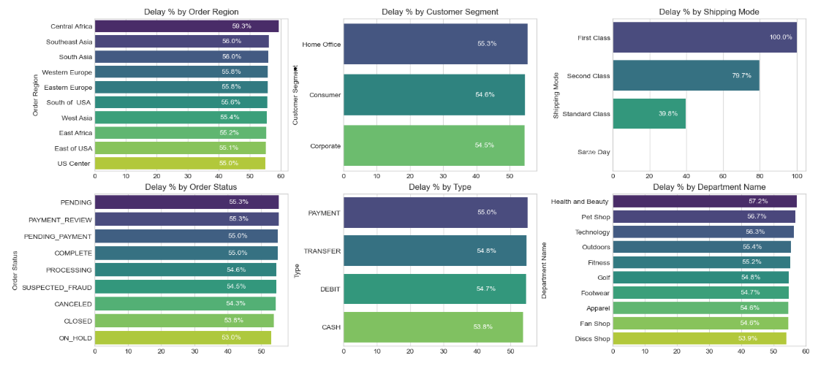
- Shipping mode is #1 Lever - First class: 100% delay rate. Second class: 79.8%, Standard class: 39.8%, Same day: 0%. The mode assignment logic is the most impactful single variable to fix.
- Regional Spread is Narrow (55-59%) - Central Africa leads at 58.7% but all regions cluster between 55-59%. This rules out a localized logistics failure and confirms a company-wide systemic issue
- Customer Segments nearly identical (54.5% - 55.4%) - No segment receives preferential service . All customers – Consumer, Corporate, Home Office – experience the same broken delivery promise.
- Health and Beauty (56.9%) and Pet Shop (56.6%) Lead by Department - These departments marginally outpace others in delivery rate, warranting an inventory and carried audit for these product categories.

- Root Cause Analysis
Central Africa was selected for deep-dive root cause analysis as the highest delay-region (58.7%). The chart below ranks the Top 10 driver factors by delay percentage within this region.
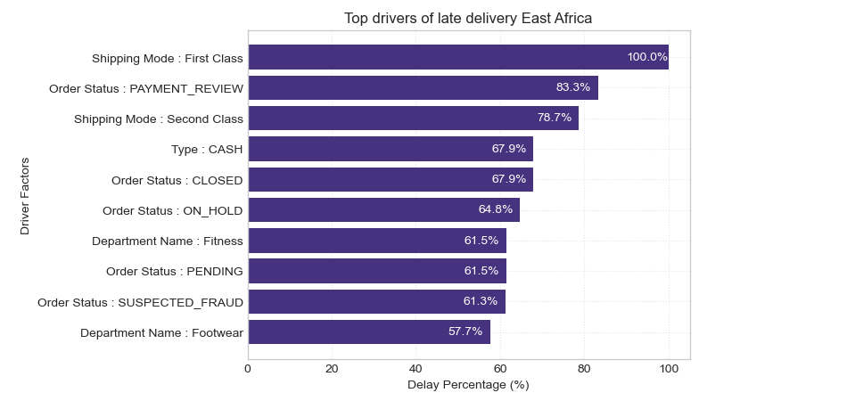
- Time-Based Delay Patterns
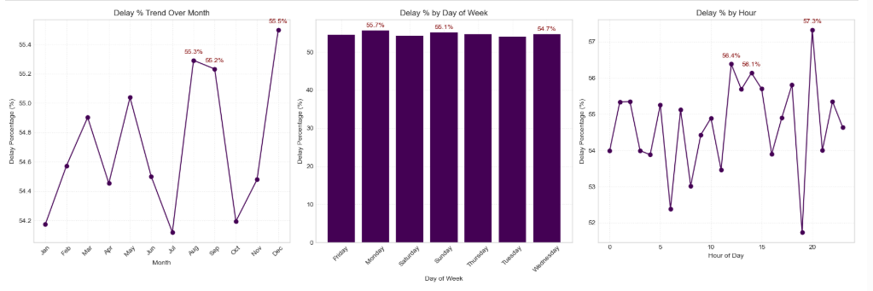
Three temporal dimensions were analyzed: month of year, day of week, and hour of day. While delay rates are relatively stable across all dimensions (53-57%) specific peaks highlight opportunities for targeted capacity planning.

- Peak Delay Months – August and September are the highest months at 55.4%, with December close behind. These reflect mid-year promotions and Q4 holiday surge overwhelming fulfilment capacity. July represents a notable low-point (-53.75%), confirming seasonal variation is plannable.
- Day-of-Week Variance is minimal – Monday(55.7%) and Sunday (55.1%) are the peak days, but the spread across the week is less than 1 percentage point. Day-of-week is not a meaningful lever for operational intervention.
- Intra-Day Peaks - Late evening orders (Hour21) have the highest delay rate at 57.3%, likely reflecting processing cut off windows. Midday peaks suggest bottleneck during peak-volume hours

- Strategic Recommendations
Based on the findings across all analytical dimensions, the following prioritized actions are recommended.
- Immediately Audit First Class and Second-Class Shipping Capacity
First class shipping has a 100% delay rate and Second class 78.7% . These modes operate in complete contradiction to their band promise. Conduct an immediate carrier SLA Audit. Until resolved, consider suspending First Class or repricing to reflect actual performance.
- Resolve Payment Processing Bottlenecks
Orders in PAYMENT_REVIEW (55.3% overall : 80.0% Central Africa) and PENDING_PAYMENT(55.0%) have significantly elevated delay rates. Introduce automatic escalation for stalled payment reviews exceeding 2 hours.
- Develop Seasonal Surge Capacity plans
August, October (55.4%), and December (55.2%) are peak delay months. Build pre-season capacity plans including temporary logistics partnerships, inventory pre- positioning and adjusted delivery promise windows.
- Default to Standard Class for Eligible orders
Standard class achieves a 39.8% delay rate – for superior to First and Second Class. Re-evaluate shipping mode assignment logic to default eligible orders to Standard Class, particularly in regions and departments with poor premium mode performance.
- Investigate High-Delay Departments in Africa
Outdoors (55.4%) and Golf (54.8%) in Central Africa show significantly elevated delay rates. Conduct a warehouse-level audit of stock availability, pick-and-pack times, and carrier assignment for these product categories.
- Reduce Loss making Order Share (18.7%)
The 187% loss-making order share warrants a separate pricing and discount review. Combine with delay analysis to identify whether discounted orders are disproportionately late, creating a compounded margin problem.

- Conclusions
This analysis has surfaced a clear and urgent picture: a global e-commerce operation where the majority of orders (54.70%) fail to meet their promised delivery windows, costing $2.1M in at-risk profit and undermining customer trust at scale.
The root causes are identifiable and addressable. Shipping mode misconfiguration (First class at 100% late, Second Class at (79.7%) is the dominant operational failure. Payment processing friction creates a secondary bottleneck. Seasonal volume spikes are not adequately planned for. And geographical disparities , while present, are secondary to systemic company-wide pattern.
Priority Area | Current State | Target State
Late Delivery Rate | 54.71% | <30% within 12 months
First Class On-Time Rate | 0% | >80%
Second Class On-Time Rate | 20.2% | >60%
Loss- Making Orders | 18.7% | <12%
Profit at Risk | $2.1M | Reduce by 40%

With focused execution on the six recommendations in this report starting with the critical shipping mode audit and predictive alert system deployment the business can systematically recover its delivery performance , protect its $7.5M profit base, and build the operational reliability that sustained e-commerce growth demands.

